**Embed a VidGrid Video in Blackboard**

**Step 1:** Record your video using VidGrid.

**Step 2:** Highlight the entire code under Embed Code and copy it.

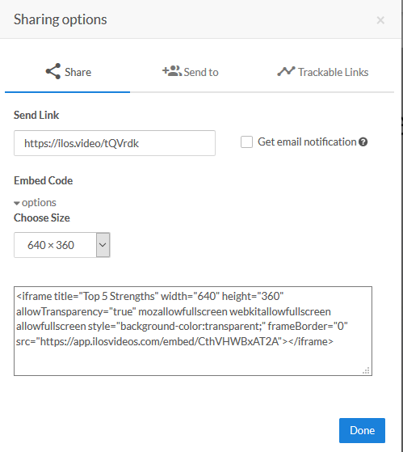

**Step 3:** Navigate to your Blackboard course and the Discussion Board area or Assignment submission area where the VidGrid video should be turned in.

**Step 4:** In the text editor box, find the HTML button and click on it.

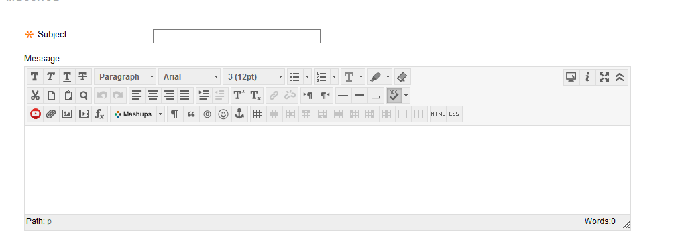

**Step 5:** In the new box that opens, paste in the embed code that was copied from VidGrid. Do not add anything to it. Click **Update**.

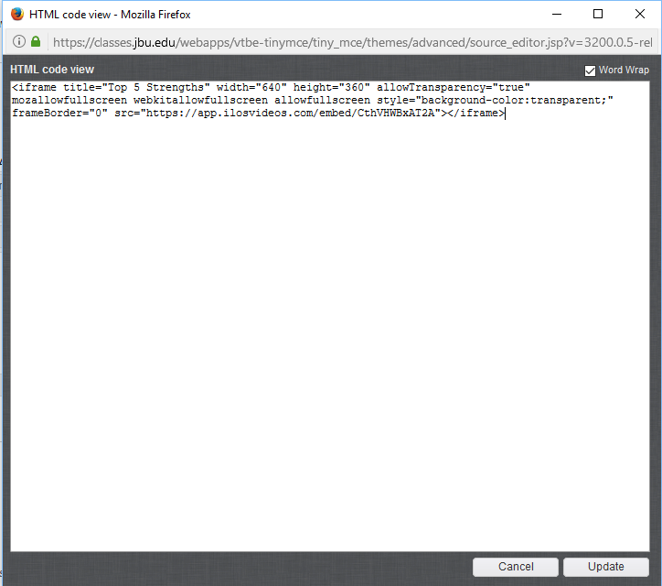

**Step 6:** The next screen will show a blank box with an outline. Click **Submit** to finish the post.

