**Hyperlink a VidGrid Video in Blackboard**

**Step 1:** Record your video.

**Step 2:** Highlight the link under Send Link and copy it, Ctrl C.

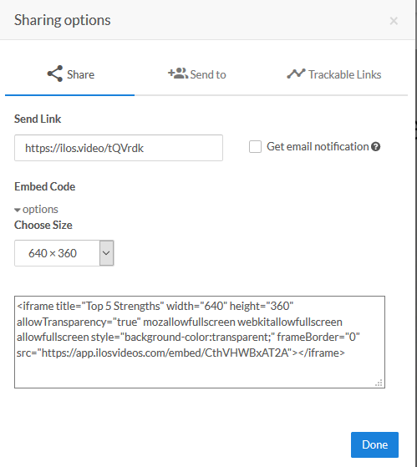

**Step 3:** Navigate to your Blackboard course and the Discussion Board area or Assignment submission area where the VidGrid video should be turned in.

**Step 4:** In the text editor box, paste in the link, Ctrl V. Highlight the entire link. Then click on the **Hyperlink** icon.

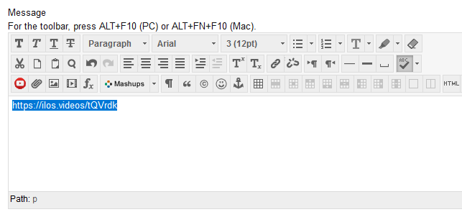

**Step 5:** In the new box that opens, paste in the hyperlink again to the **Link Path** box. Change the **Target** to ***Open in New Window***. Then click **Insert.**

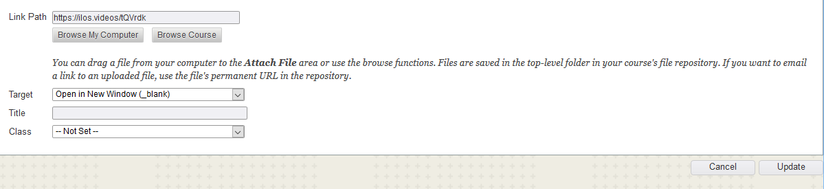

**Step 6:** The link will now be underlined in the text editor. Click **Submit** to finish the post.

